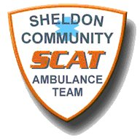
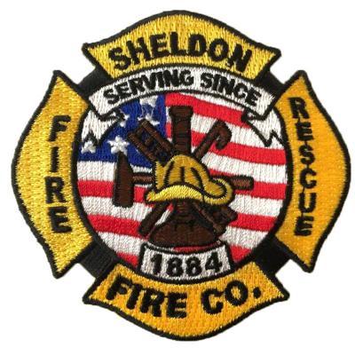

APPLICATION FOR MEMBERSHIP
Sheldon Fire Company, Sheldon Community Ambulance Team (SCAT), Sheldon Emergency Management Agency (EMA)
Please, circle the agency you’re applying for:

Fire SCAT EMA

GENERAL INFORMATION
Last Name: First Name: Middle Initial:
Address: DOB:
City, State, Zip Code:
Telephone Number(s): _____________________
Email Address:
EMPLOYMENT EXPERIENCE
Start with your present or last job. Include any military service assignments or volunteer activities.
Employer: Dates Employed:
Address:
Telephone Number:
Job Title:
Work Performed:
Reason for Leaving:
Employer: Dates Employed:
Address:
Telephone Number:
Job Title:
Work Performed:
Reason for Leaving:
EDUCATION
High School
Name: Years Completed:
Address: Diploma:
College
Name: Years Completed:
Address: Degree(s):
Course of Study: ____________________________________________________________________
ADDITIONAL INFORMATION
List any training you have received in First Aid, CPR, firefighter or other related training:
1. Date Completed:
2. Date Completed:
3. Date Completed:

Other Qualifications:
Summarize any other skills or experiences, which may be of value to our team.

REFERENCES:
List three references that are not related to you and are not previous supervisors.
1) Name & Address: Telephone Number: Years Known:
2) Name & Address:
Telephone Number: Years Known:
3) Name & Address:
Telephone Number: Years Known:

Do you agree to take a post-offer assessment as required? Yes No
Do you consent to a driver’s license check to verify your driving record? Yes No
Are you now or has an automobile insurance company rated you in the past as a sub-standard risk? Yes No
If yes, explain
Have you ever been convicted of a crime in this state or any other state? Yes No
If yes, explain
Do you agree, that in addition to your duty time, you will attend regular meetings, drills, and training sessions required to properly maintain an efficient service? Yes No

If applying for SCAT, please complete the following:

Do you agree to complete the EMT-B course within a year of this application? Yes No

Applicant consent:
I hereby agree to abide by SCAT’s constitution, by-laws, and rules, and to adhere to the city, county, state, and
federal laws and ordinances, which govern the operation of this ambulance service. The information provided is
true to the best of my knowledge.

I acknowledge that I have made application for membership to the Sheldon Community Ambulance Team (SCAT). I hereby consent to have the City of Sheldon request a transcript of my driving record from the Iowa Department of Transportation. I consent to have the transcript of my driving record attached to my application for determination of membership by the City of Sheldon. ATTACHED IS A COPY OF MY CURRENT DRIVER’S LICENSE.

Applicant Signature: Date: ________________________________
SCAT Director Signature: ________________________________________Date: _______________________________

If applying for the Sheldon Fire Co., please complete the following:

Marital Status: _____________________ Spouse: ____________________________________ Spouse contact info: ___________________________________
Physical Disabilities or limitations: _______________________________________________________________________________________________________
Emergency Services History: ______________________________________________________________________________________________________________

Applicant Consent:
I realize that the Sheldon Fire Company is not a social club and that as a member I will be required to give freely of
my time and talents. It is required to attend all emergency calls, meetings, trainings, and classes possible. I agree to
attend and pass all of the required training as soon as possible. I also agree to a physical exam prior to service and during my tenure. I understand that the Sheldon Fire Company/City of Sheldon will run a background check and
driving record prior to my service.
Applicant Signature: _______________________________________ Date:_______________________
Spouse Consent:
I realize that if my spouse is accepted for membership to the Sheldon Fire Company, they will be giving part of their
time to public services. I understand that if my spouse accepts to membership, I am automatically part of the
Auxillary and agree to attend meeting and functions of said Auxillary.
Spouse Signature: __________________________________________ Date: _______________________
Employers Consent:
I do hereby signify that this application is made with knowledge and consent. I realize that my employee will
possibly be late for or leave early from work due to the need of public service.
Employers Signature: ______________________________________ Date: __________________________

Agreement to Reimburse the City of Sheldon for expenses:

________________________________, as applicant to the Sheldon Fire Company, does hereby agree to pay back the City of
Sheldon for the costs of the physical assessment as follows.
- Leave within one year of joining.
- Doesn’t get voted on the Sheldon Fire Company at the end of the probationary period.
- If removed from the Sheldon Fire Company for violation of the by-laws of the department.

Applicant Signature: _________________________________________ Date: ______________________________________
Parent/Guardian (students): ___________________________________________ Date: ___________________________
Fire Chief: ___________________________________________________ Date: ________________________________________

If applying for Sheldon EMA, please complete the following:

Applicant Consent:

I understand that if this application is approved, I will become a member of the Sheldon Emergency Management
Agency. I agree to abide by the rules and regulations governing the operation and activities of the Agency as set out
by the Sheldon City Council and the Sheldon Emergency Management Agency. I understand that I am subject to rules
and regulations governing this program.
Applicant Signature: ________________________________________ Date: _________________________

