City of Sheldon
Zoning Permit Application
PERMIT MUST BE FILLED OUT IN ITS ENTIRETY OR IT WILL BE RETURNED

CITY CODE, CHAPTER 23.3, ZONING PERMITS REQUIRED: "NO BUILDING OR OTHER STRUCTURE SHALL BE ERECTED, MOVED, REMODELED OR ADDED TO, WITHOUT A ZONING PERMIT THEREFORE ISSUED BY THE ZONING ADMINISTRATOR. NO PERMIT SHALL BE ISSUED EXCEPT IN CONFORMITY WITH THE PROVISIONS OF THIS CHAPTER, EXCEPT BY WRITTEN ORDER BY THE BOARD OF ADJUSTMENT." sheldoniowa.gov/documents.

PROPERTY OWNER INFORMATION APPLICANT (If other than PROPERTY OWNER)

Name: Cell Phone: Name: Cell Phone:

Address: Address:

Address of Proposed Work: Email:

Email: Builder:c Contractor:c Design Professional: c

SPECIAL NOTE: THE LOCATION OF PROPERTY LINES & EASEMENTS IS THE SOLE RESPONSIBILITY OF THE PROPERTY OWNER. THE CITY OF SHELDON DOES NOT AND WILL NOT LOCATE PROPERTY LINES OR EASEMENTS. THE CITY ACTS ON INFORMATION PROVIDED ON THIS FORM. INACCURATE INFORMATION ON THIS FORM CAN RESULT IN PERMIT NON-ISSUANCE, REVOCATION, AND/OR LEGAL ACTION. IT IS HIGHLY RECOMMENDED A LICENSED LAND SURVEYOR BE USED TO ESTABLISH THE LOCATION OF PROPERTY LINES. I UNDERSTAND THAT IF ANY CONSTRUCTION OR PLANTINGS OCCUR IN EASEMENTS, AND IT IS NECESSARY FOR THE CITY OR UTILITY COMPANY TO ACCESS SUCH EASEMENT, NO COMPENSATION SHALL BE GIVEN FOR SUCH DISTURBANCE.

YARD MEASUREMENTS (Setback Distances from Property Lines, NOT STREETS)
Please do not mark with X’s. Must be measurements (in feet) from the property lines

Front Yard (from proposed building/structure to front lot line) ft. Right Side to side property line ft. (as applicable)

Rear Yard (from proposed building/structure to rear lot line) ________ft. Left Side to side property line _ ft (as applicable)

DETAILED DESCRIPTION OF PROJECT

What do you want to build? Describe in detail:

CONTRUCTION INFORMATION

Est. Start Date: Est. Completion Date: _________ Project Cost: $ Zoning Designation:

General Contractor (Name, Phone & Email):

Plumbing (Name, Phone & Email):

Electrical (Name, Phone & Email):

Excavating (Name, Phone & Email):

For New Construction/Building Addition/Accessory Building (garages/sheds) Projects:

Size of Bldg./Structure: __ ft. X ft. Height of Bldg./Structure: __ ft. Foundation Depth _____ ft. Number of Parking Stalls: _____

For Fence/Wall/Retaining Wall Projects:

Location: ___ Front Yard ___ Rear Yard Side Yard Height: ft. Length: ____ ft. Width:____ ft. Distance to property line: _____ ft.

For Deck/Patio/Steps/Ramp Projects:

Location: ___ Front Yard ___ Rear Yard Side Yard Height: ft. Length: ____ ft. Width:____ ft. Distance to property line: _____ ft.

TYPE OF CONSTRUCITON OR PROJECT Check ALL that Apply:
New Construction Bldg. Addition Accessory Bldg. (shed/garage) Demolition Moving Fence
Residential Commercial Industrial Recreational Government/Public ____ Egress Window
Single Family Dwelling Duplex Dwelling Multi-Family Dwelling Other Project: _______

DESCRIPTION OF BUILDING MATERIALS Check ALL That Apply:

Wood Frame Metal Frame Concrete Stone or Brick (Real or Veneer) Wood Siding ___ Metal Siding Vinyl Siding

____ Other Building Materials: ___ Building materials (detail of materials or provide images to ensure compliance with conformance rules): _________________________________ _______________

Roofing Materials: Asphalt Metal (non-corrugated) Metal Shingle Membrane (flat roof) Other: ______________

Sheldon Zoning Permit Application
- Page 2 -

SITE PLAN REQUIREMENTS
_____ SITE PLAN ATTACHED WITH THIS APPLICATION (check for attached site plan prepared as specified below)
New construction single family residential, multiple family residential, civic, commercial, and industrial projects should provide architectural drawings, property survey or plot plan along with the application. Smaller project site plans should include:
- Draw the lot showing lot measurements. Lot measurements may be obtained from the O’Brien County Assessor’s website
Note: Curb line is NOT the front property line. Where a sidewalk exists, the front property line is typically the inside edge of the sidewalk.
- Show all existing and proposed new buildings or structures with dimensions of all new building or structures
- Show the distance between all existing and proposed buildings and the nearest lot or property lines
- Label adjacent streets and indicate alleys and easements as applicable. Use directional arrow to indicate north.
- The city reserves the right to require additional information necessary to review the proposed project.

CHECKLIST
Is the application filled out and accurate in its entirety? IE: Setbacks are from the LOT LINE and NOT back of curb.
Is a site plan, survey, or drawings & images provided of the project?
Is the project located in a floodplain that would otherwise require additional review?
For new construction, be aware there are typically water/sewer connection fees.
For new construction, will a new sidewalk be installed, or sidewalk repaired if already existing?
(See Sec. 16.6 of the Zoning Code and Sec. 136.08 of the City Code for sidewalk requirements)

ADDITIONAL INFORMATION/DISCLOSURE:
RETURN COMPLETED AND SIGNED APPLICATION TO THE SHELDON COMMUNITY SERVICES CENTER AT 416 9TH STREET. PERMIT EXPIRES ONE (1) YEAR AFTER ISSUE DATE. AFTER ONE YEAR, A NEW PERMIT APPLICATION IS REQUIRED. THE ZONING PERMIT FEE IS SET BY RESOLUTION OF THE CITY COUNCIL AND PAYABLE WHEN THE PERMIT IS ISSUED. PERMIT FEE SHALL DOUBLE IF CONSTRUCTION STARTS BEFORE THE PERMIT IS APPROVED. IT IS THE APPLICANT’S RESPONSIBILITY TO NOTIFY IOWA ONE-CALL (1-800-292-8989 OR 811) BEFORE ANY EXCAVATION BEGINS. ALL NEW CONSTRUCTION REQUIRES INSTALLATION OF SIDEWALK ABUTTING PUBLIC ROADWAYS IN SHELDON. AS PER CITY CODE. THIS STIPULATION DOES NOT APPLY IF SIDEWALKS ALREADY EXIST. FAILURE TO CONSTRUCT SIDEWALKS WILL RESULT IN LEGAL ACTION. IT IS THE APPLICANT’S RESPONSIBILITY TO DETERMINE IF ANY SUBDIVISION COVENANTS, DEED RESTRICTIONS, OR EASEMENTS AFFECT THE PROJECT. ABSOLUTELY NO PERMIT WILL BE ISSUED ON THE SPOT. THE ZONING ADMINISTRATOR MAY REQUIRE A CONFERENCE BEFORE ISSUANCE.

ACKNOWLEDGEMENT & SIGNATURE
The applicant, by signing, acknowledges and agrees to the conditions of this permit; and that the provisions of the Sheldon Zoning and Subdivision Ordinances and Sheldon Code of Ordinances may be applicable to the submitted project. I hereby will defend, indemnify, protect, and hold harmless the City of Sheldon and its employees from any and all liability from any claim or cause of action which any person may claim to have by reason of any actual or alleged failure on the part of the undersigned applicant to comply with the terms and provisions thereof. I hereby certify that I have read and examined this application and its attachments and know the same to be complete, true, and correct. All laws and ordinances governing this type of work shall be adhered to whether specified herein or not. I agree and will provide notification of any change prior to construction. The granting of this permit does not presume to give authority to violate or cancel the provision of any other state or local laws regulating construction. This permit allows construction of the proposed building/structure as noted on this application and any submitted documentation. Any unauthorized change to approved permit and plans, or use of property, as presented will render this permit null and void.

Signed: ___________________________________________________________________________________________________ Date: ____________________
Property Owner

Signed: ___________________________________________________________________________________________________ Date: ____________________
Contractor, Applicant, or other Authorized Representative (if Owner is not completing the work)

CITY OFFICE USE ONLY
Reviewed by: _______________________________________________ Date: _____________
Zoning Administrator or Authorized Representative

Approved by: _______________________________________________ Date: _____________
City of Sheldon Authorized Representative

Approved c Denied c Conditional Approval c - if conditional approval, conditions required:

Review comments: _____________________________________________________________
_____________________________________________________________________________

Permit Request Requires: Variance c Conditional Use c Change of Zoning Classification c

If required, forwarded to P&Z or Board of Adjustment on: ________________________ (date)

Lot Size (sq.ft.): |  | Zoning District:
Legal Description (lot, block, subdivision):
Required Yard Setbacks (by Ordinance)
Front: _________ | ___ Side: _________
Rear: __________ | ___ Side: _________
Permit Fees: $ | Date Paid:

Sheldon Zoning Permit Application
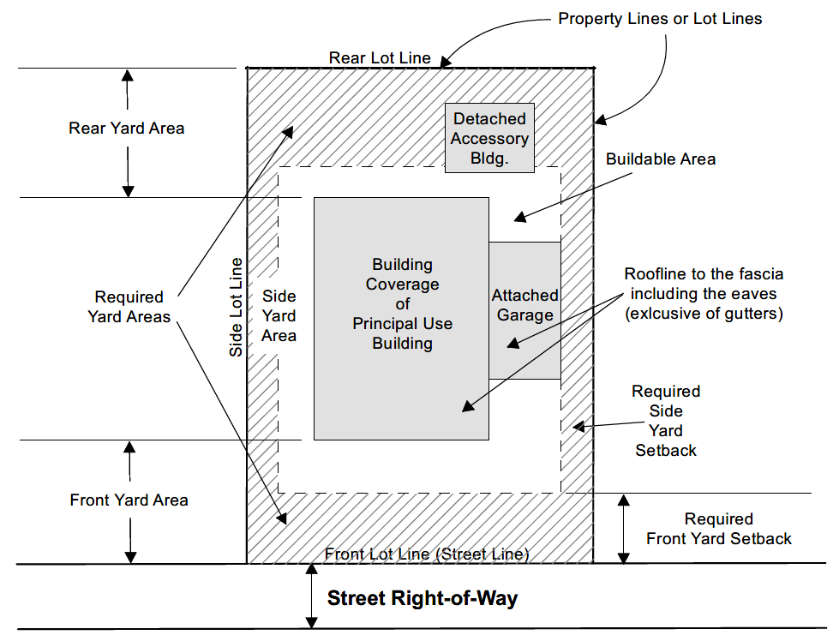
- Page 3 -

Sheldon Zoning Permit - Site Plan

Applicant:
Address:

Please Submit below a sketch plan showing the actual shape and dimensions of the lot on which the construction will take place
- Show streets, with street names, if any on proper sides of the lot or parcel
- Show property lines and dimensions of the lot or parcel
- Show locations of any existing and proposed new structures, and their distances from the lot lines
- Show locations of any existing and proposed accessory buildings (if any), and their distances from the main building and lot lines
- Show locations of utility and other permanent easements
- Show details of fences, shrubs, walls or other devices used for screening (if applicable)
- Beacon (schneidercorp.com) is an excellent source for information and usually has a good map available.

